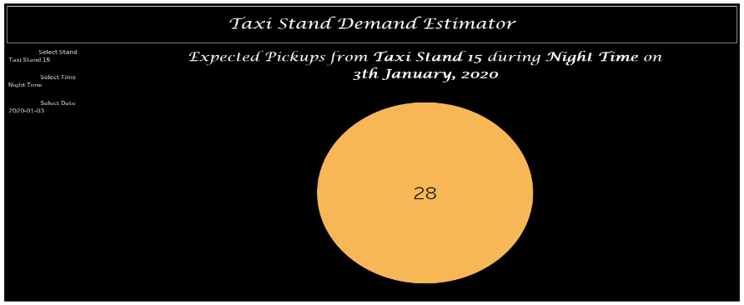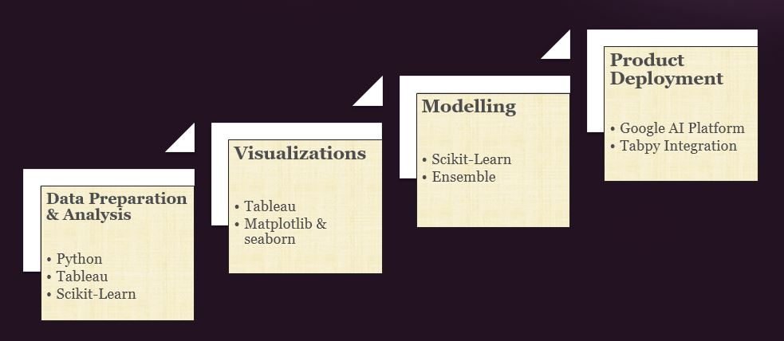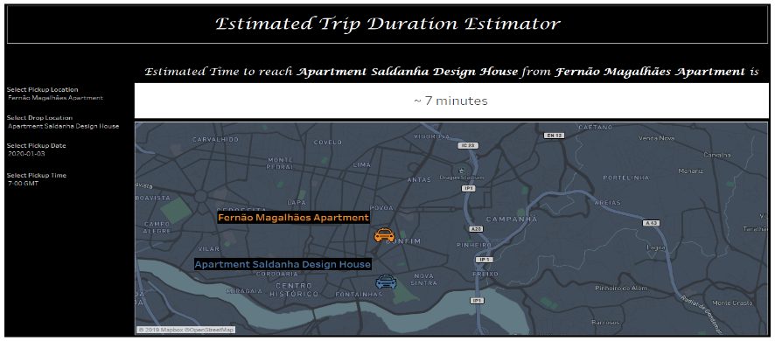

*Key Insights*

* 47%+ trips originate at taxi stands
* Demand at Campanha Railway Station (Stand Id – 15) is consistently high compared to other taxi stands
* Demand at St John hospital (Stand ID – 33) is more at Night time
* Demand at Shopping center (Stand Id – 23) is more on Weekends
* Although there is huge demand of taxi’s (both to and fro) from Airport, there is no designated Taxi Stand over there

*Methodology*

* **Taxi tracking data**
* 440+ taxis in Porto city, Portugal
* GPS coordinates for taxi movement every 15 sec
* 1.7 million unique trips between July 2013 to June 2014
* **Key observations:**
* Trip duration for 99% of trips is <60 min
* Trip duration for 10% of trips is <5 min
* Distance travelled for 95% of trips is <15 km
* Distance travelled for 1% of trips is > 24 km
* **Missing Data:**
* 5900+ trips don’t have any GPS coordinates
* 11000+ trips from taxi stand have missing
* Stand IDs

*Sample Screenshots*

*Data Undertanding*

*Problem Statement*

**ShAn** Taxi Services

* Taxi service provider having operations across Europe
* Manage their own taxis
* Quality of Taxis and Professionally groomed chauffeurs
* Entering Porto as part of their expansion plan

*Deliverables*

*Executive Summary*

*Porto Cab Data Analysis*

*Objective*

* Key insights from the data pertaining to taxi usage in Porto
* TMV - Taxi movement visualizer
* TSD - Taxi Stand Demand Estimator
* TDE – Trip Duration Estimator
* Identify which model they should go with (Call a cab or Taxi Stand)
* Identify the key areas in Porto to maximize taxi utilization
* Provide AI enabled tools to help them be agile in their decision making

Congue nihil imperdiet doming id quod mazim placerat facer minim veni am ut wisi enim ad minimeniam, quis erat nostr uexe

rci tation ullamcorper nostru exerci tation ullam corper et iusto odio dig nissim qui blandit praesent lupta. Tummer delenit

augue duis dolore te feugait nulla facilisi. Con erattis sectetuer adip iscing elit, sed erat diam nonummy nibh magna erat.

*Opening Doors*

*for Homeowners*

*Like You*